Git Large File Storage

What is Git Large File Storage
# Source: AI Source: Provided by: [Data Path: Persons Table -> ID Column: 1, Name_En Column: Motasem Essam] -> From: [Chatgpt (GPT‑5 Mini)] on [3/6/2026]
Git Large File Storage (Git LFS) is an extension to Git designed to handle large files efficiently. By default, Git stores every version of every file in the repository, which can become very slow and heavy when dealing with large assets like videos, high-resolution images, datasets, or binaries. Git LFS solves this problem. Here's how it works in detail:

Key Concepts of Git LFS
# Source: AI Source: Provided by: [Data Path: Persons Table -> ID Column: 1, Name_En Column: Motasem Essam] -> From: [Chatgpt (GPT‑5 Mini)] on [3/6/2026]
- Pointer Files Instead of Full Files
  - When you add a large file to a Git repository with Git LFS enabled, Git doesn’t store the file content directly.
  - Instead, Git stores a small pointer file that references the actual file in a separate storage location.
- External Storage
  - The actual large files are stored in a remote LFS server (often the same server as your Git hosting provider, like GitHub, GitLab, or Bitbucket).
  - When you clone or pull the repository, Git LFS automatically downloads the real files referenced by the pointers.
- Efficient Versioning
  - Only the differences in the large files (or new versions) are stored, so your main repository remains lightweight.
  - This prevents repository bloat and keeps Git operations like cloning, fetching, and branching faster.
- File Types
  - Commonly used for: .mp4, .mov, .psd, .zip, .iso, .h5 (machine learning datasets), and other large binaries.
  - You can configure which file types to track with Git LFS using the git lfs track "*.ext" command.

How It Works in Practice
# Source: AI Source: Provided by: [Data Path: Persons Table -> ID Column: 1, Name_En Column: Motasem Essam] -> From: [Chatgpt (GPT‑5 Mini)] on [3/6/2026]
- Install Git LFS:
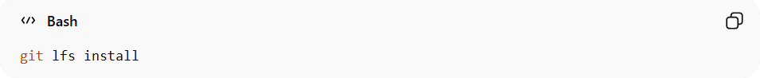
git lfs install
- Track a file type:
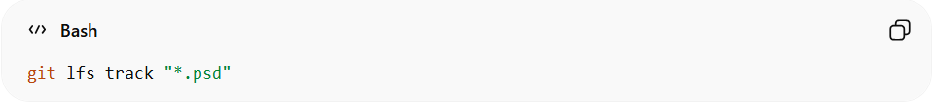
git lfs track "*.psd"
- Add and commit as usual:
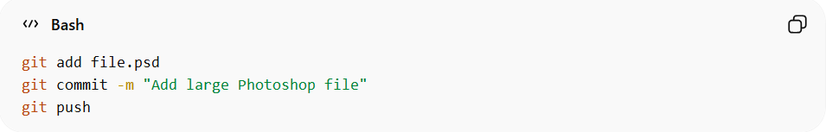
git add file.psd
git commit -m "Add large Photoshop file"
git push
Git LFS will automatically upload the actual file to the LFS server, while Git stores only a lightweight pointer.

Disable Git LFS in a Repository
# Source: AI Source: Provided by: [Data Path: Persons Table -> ID Column: 1, Name_En Column: Motasem Essam] -> From: [Chatgpt (GPT‑5 Mini)] on [3/6/2026]
If you just want to stop using Git LFS for a repo:
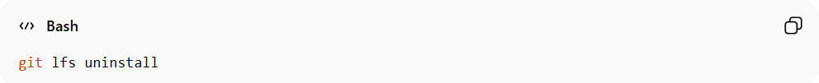
git lfs uninstall
- This removes Git LFS hooks from your current repository.
- Existing files already tracked by LFS remain as pointer files unless you convert them back (see below).
If you want to convert LFS-tracked files back to normal Git files:
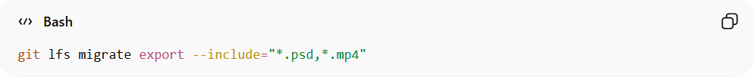
git lfs migrate export --include="*.psd,*.mp4"

specify the file types you tracked

Benefits
# Source: AI Source: Provided by: [Data Path: Persons Table -> ID Column: 1, Name_En Column: Motasem Essam] -> From: [Chatgpt (GPT‑5 Mini)] on [3/6/2026]
- Reduces repository size.
- Speeds up cloning and fetching operations.
- Keeps Git history manageable for projects with large files.

Example

How It Works in Practice
# Source: ScreenShots Source: Provided by: [Persons Table -> ID Column: 1, Name_En Column: Motasem Essam] -> Tool: [Lightshot Program] -> From [Operating System: Windows] on [3/6/2026]
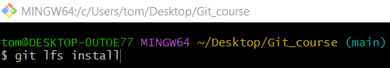
git lfs install
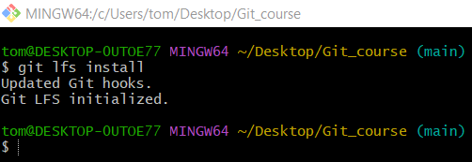
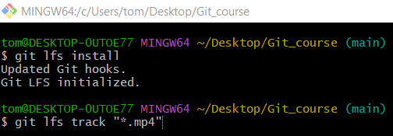
git lfs track "*.mp4"
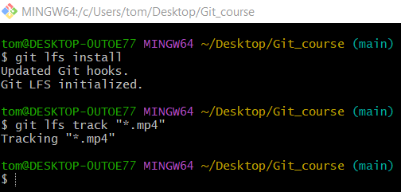
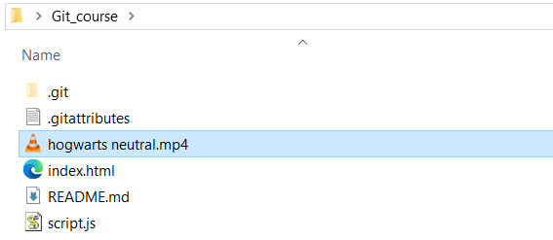
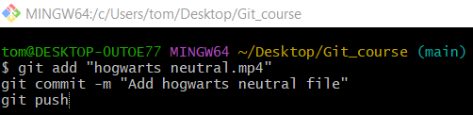
git add "hogwarts neutral.mp4"
git commit -m "Add hogwarts neutral file"
git push
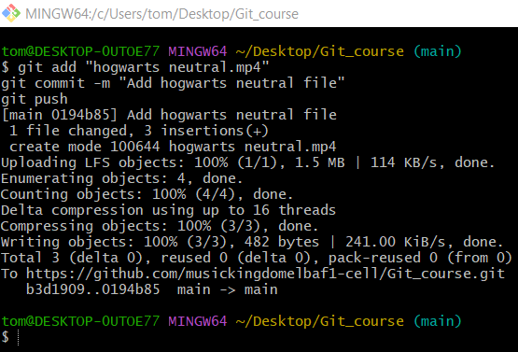

Disable Git LFS in a Repository
# Source: ScreenShots Source: Provided by: [Persons Table -> ID Column: 1, Name_En Column: Motasem Essam] -> Tool: [Lightshot Program] -> From [Operating System: Windows] on [3/6/2026]
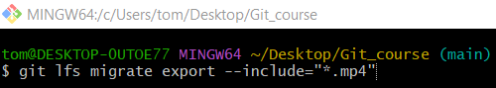
git lfs migrate export --include="*.mp4"
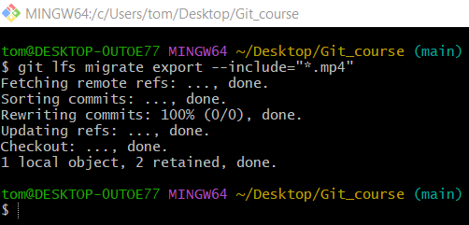

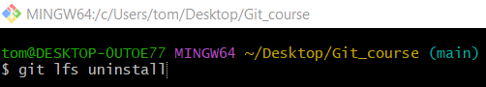
git lfs uninstall
